**INFO SHEET #3: Choosing a Topic, Writing the Introduction**

**Competency**

**MELC:** Compose a research report on a relevant social issue.

**Objectives**

After the end of the lessons, the learners are expected to be able to:

1. identify how to select research topic as a step in composing a research report;
2. identify different types of questions; and develop a research questionnaire to help gather data for the research report.
3. write an introduction as a part of a research report.

**Key Information**

A **research topic** is a subject or issue that a researcher is interested in when conducting research. A well-defined research topic is the starting point of every successful research report. Choosing your topic is the first step in the research process. Be aware that selecting a good topic may not be easy. It must be narrow and focused enough to be interesting, yet broad enough to find adequate information.

**How to Select and Limit a Research Topic**

***Brainstorm for Ideas*** – **Brainstorming** is a technique that can help you in generating idea. Pick a topic that you are interested in. As much as possible choose something that keeps your interest. Make a long list of possible choices and begin the selection process.

***Identify the sources of General Background Information*** – For background information, try to read encyclopedia article, journal, book on two or three topics you are considering. Background information may also be obtained from dictionaries, handbooks, statistical guides, almanacs, or biographical sources.

***Focus on Your Topic*** – Keep it manageable. A **subject** of a research paper is the general content. A **topic** is the specific issue being discussed. Try to limit your topic. Common ways to limit a topic are: by geographic region, by culture, by time frame, by discipline, by population group.

***Make a List of Useful Keywords*** - **Keywords** are used to describe your topic. Keep a list of these words to use later as you search in catalogs and other online databases.

***Be flexible***. Modify your topic during the research process. Keep in mind the assigned length of the research paper, project, bibliography and other research assignment.

***Define your topic as focused Research Question*** – You will often begin with a word, develop a more focused interest in an aspect of something related to that word, then begin to have a question about the topic.

***Formulate a Thesis Statement***. Write your topic as a thesis statement. Your **theses statement** will usually be one or two sentences that states what is to be answered, proven or what you will inform your audience about your topic.

References:

Villalobos, John Lerry F. (2020). PIVOT 4A Learner’s Module Quarter 2 p. 7

Mensalvas, Athan (2014, August 15). Strategies for developing listening skills. Retrieved December 2, 2020, from <https://www.slideshare.net/athanmensalvas/strategies-for-developing-listening-skills-38040043>

Morley, Catherine (n.d.). Listening: Top down and bottom up. Retrieved December 2, 2020, from https://www.teachingenglish.org.uk/article/listening-top-down-bottom

Tennant, Adrian. (2020). Listening matters: Top-down and bottom-up listening. One-stop English. Macmillan Education Limited. Retrieved from https://www.onestopenglish.com/listening/listening-matters-top-down-and-bottom-up-listening/154567.article

**Proposed Performance Tasks**

**WRITING THE INTRODUCTION**

When writing the introduction section of a research journal article, Bhatia (1993), Reid (2006) and Swales and Feak (2014) proposes the use of Swales’ Creating a Research Space (CARS). The model is composed of three-moves that help identify the background, motivation, and focus of the research. This framework can help give your reader a basic overview of your research report. These moves are explained in the table below

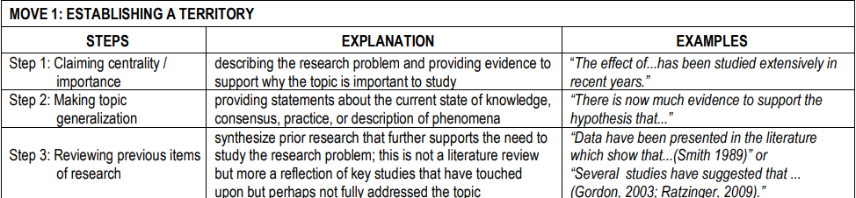

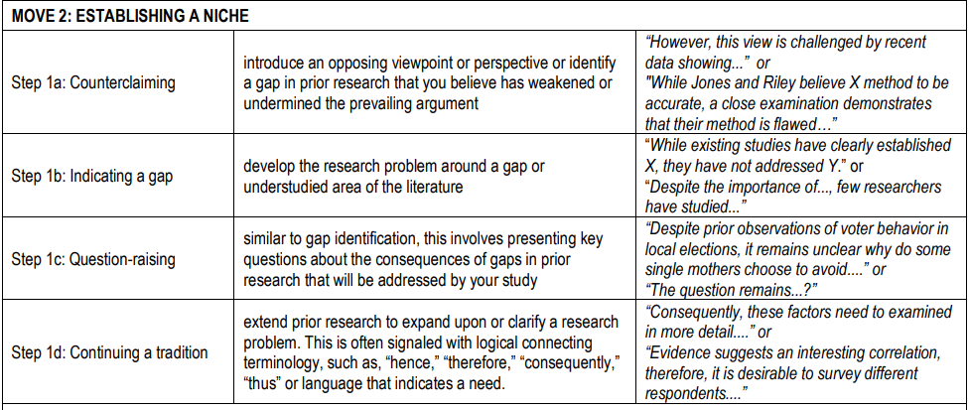

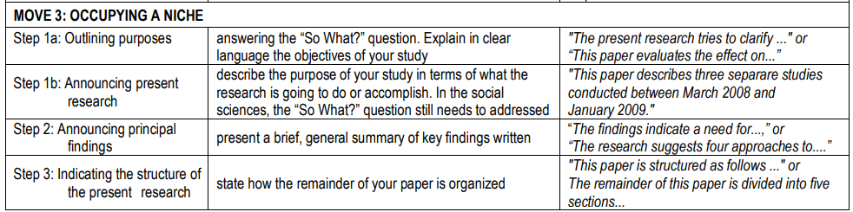

References:

Villalobos, John Lerry F. (2020). PIVOT 4A Learner’s Module Quarter 2 p. 7

Mensalvas, Athan (2014, August 15). Strategies for developing listening skills. Retrieved December 2, 2020, from <https://www.slideshare.net/athanmensalvas/strategies-for-developing-listening-skills-38040043>

Morley, Catherine (n.d.). Listening: Top down and bottom up. Retrieved December 2, 2020, from https://www.teachingenglish.org.uk/article/listening-top-down-bottom

Tennant, Adrian. (2020). Listening matters: Top-down and bottom-up listening. One-stop English. Macmillan Education Limited. Retrieved from https://www.onestopenglish.com/listening/listening-matters-top-down-and-bottom-up-listening/154567.article

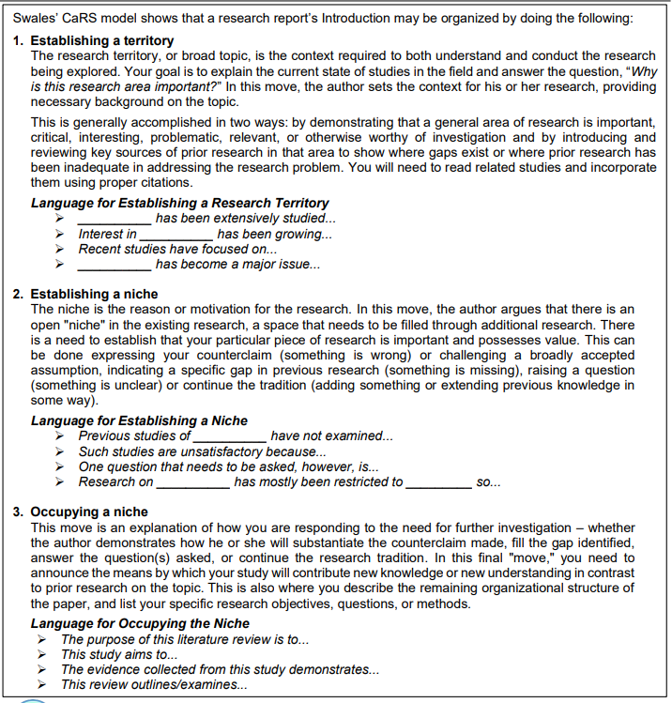

**Performance Task**

***Think About This!***

Think about a research topic on a relevant social issue that you would like to study or investigate. Recall the ways to select and limit a research topic for your teacher’s approval.

|  |  |
| --- | --- |
| **Research Parts** | **Answers** |
| Subject |  |
| Topic |  |
| Keywords |  |
| Thesis Statement |  |
| Possible sources of information: |  |
| Descriptive Question |  |
| Comparative Question |  |
| Causal Question |  |