**INFO SHEET #3: Conventions in Citing Sources**

**Competency**

**MELC:** EN8SS-IIIg-1.6.4: Use conventions in citing sources.

**Objectives**

After the end of the lessons, the learners are expected to be able to:

1. Identify the pattern of writing citation per material

2. Write proper citations for books, newspapers, photos, websites, and interview.

**Key Information**

There are various ways in acknowledging sources. One of these is the APA 7th edition format. Introduced by the American Psychological Association, the APA is considered as one of the largely used referencing style in terms of research and other academic endeavors.

The APA 7th edition format features a number of ways in citing authors and their work. In this lesson, a few will be highlighted to guide you in basic referencing styles.

1. **BOOKS**

* Single Author

Bermudez, L. (2017). *The journey to the end of Asia* (2nd ed.). RELC Press.

De Chavez, J. (2020). *Pagsibol: Batayang aklat sa pagkatuto sa Filipino.* Agila

Publishing House.

* Two Authors

Cadavido, J. S., & Bermudez, L. (2017*). Living as students overseas.* RELC Press. https://relc.org.sg/Living_as_students_overseas

Balaogan, E. T., & Cargullo, L. C. (2017). *Understanding the complex behavior of adolescence* (4th ed.). Cainta & Cainta.

* Edited Book (Editors) with No Author

Marlina, R. G. (Ed.). (2017). *Living as students overseas*. RELC Press.

Panga, A. F., & Chua, T. D. (Eds.). (2018). *Curriculum management in ASEAN member-states.* ASEAN Press.

* Edited Book with an Author/s

Cadavido, J. S., & Bermudez, L. (2017). *Living as students overseas*. R. G. Marlina (Ed.). RELC Press.

Gibas, E. F., & Lopo, J. E. (2018). *Curriculum management in ASEAN member-states.* A. F. Pang & T. D. Chua (Eds.). ASEAN Press

* With Three (3) to 20 Authors

Include all the names until the 20th author.

Cadavido, J. S., Alonzo, B. A., Condes, R. C., Red, M. N., Villaverde, M. A., Mirabel, A. I., Catchuela, R. L., Lavides, M. A., Berina, A. P., Cunanan, A. J., Villapena, A. S., Zubieto, S. J., Tibordo, J. R., Regulto, D. J., Perez, R. T., Balane, I. A., Azul, P. B., Narvaez, J. M., Banal, C. A., & Ortiz, A. T. (2019). *Teaching English as a second language* (8th ed.). Sampaguita Publications.

* With More Than 20 Authors

If there are more than 20 authors, write the names of the first 19 authors, followed by an ellipsis (…) and then the last author.

Dino-Aparicio, C., Guerrero, J. L., Araojo, K. U., Catungal, R. G., Caya, A. M., De Leon, S., Manalo, J. R., Mendoza, L. N., Olar, S. Q., Oyardo, J. M., Lopez, J. N., Retardo, R. O., Somodio, A. O., Ware, V. P., Dizon, A. M., Exconde, G. L., Ferrer, A. D., Limbo, F. T., Llegado, A. L., … Maano, M. R. (2019). *Understanding English as an international language.* Bantayog Publishing House.

**2. Newspapers**

Name of the Author. Year, Month, Day Published. “Article Title.” Newspaper Title [City], page numbers.

Cortez, A. (2005, July 7). “Dealing with Insomnia”. Philippine Star. pp. A2.

1. **Website**

This refers to the collection of files and related resources accessible through the World Wide Web and organized under a domain name.

This is the sample format of writing a website bibliography:

Author’s last name and first name. “Page Title.” *Website Title*, Published Date/Access Date. URL.

Orcullo, Ramon Jr. “Solid Faith.” *Department of Education Caraga Region*, June 2, 2020. http://caraga.deped.gov.ph/solid-faith/

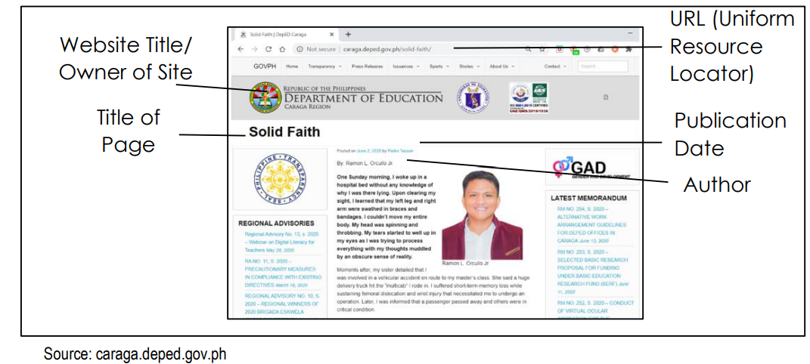

## **4. Interview**

* Person Interviewed

Name of person interviewed. Type of interview. Date of interview.

Soriano, A. (2008, April 5). Email interview.

## **4. Photos**

* **References:**

Artist Surname, First Initial. Second Initial. (Year). Title of the artwork [Format]. Title of the Website. URL (address of web site)

* **References (No Author):**

Title of work [Type of work]. (Year image was created). Title of the Website. URL (address of web site)

* **References (No Author, No Title, No Date):**

[Subject and type of work]. Title of the Website. URL (address of web site)

Example:

* **References (Basic):**

Baumel, A. (2010). Cholera treatment center in Haiti [Online image]. Doctors Without Borders. https://www.doctorswithoutborders.org

* **References (No Author):**

Flu epidemic [Online image]. (1919). History. http://www.history.net/photo/flu-epidemic-art/collections

* **References (No Author, No Title, No Date):**

[Untitled illustration of a sleeping dog]. Sleeping Animals. http://www.sleepinganimals/pix.com

Reference:

Regional Office Management and Development Team & Schools Division Office Development Team. (2020). *PIVOT IV-A Learner’s Material. English Grade 8 Quarter 1.* (1st Edition). Department of Education Region IV-A CALABARZON.

References:

Villalobos, John Lerry F. (2020). PIVOT 4A Learner’s Module Quarter 1 p. 20-21

**Proposed Performance Tasks**

The students will visit the library/reading corner to cite books, newspapers, photos, websites, and interviews using APA 7th Edition format.