**INFO SHEET #4: Evaluating and Making Judgments**

**Competency: EN10LC-lle-13.2.** Evaluate and make judgements about a range of texts using a set of criteria e.g., comparing arguments on the same topic, critiquing a short story.

**MELC:** Evaluate and make judgements about a range of texts using a set of criteria e.g., comparing arguments on the same topic, critiquing a short story.

**Objectives**

After the end of the lessons, the learners are expected to be able to:

1. determine the indicators in evaluating a text,
2. utilize the criteria in evaluating a text, and
3. appreciate the importance of using a standard *(set of criteria)* in establishing objectivity in evaluating a text.

**Key Information**

**EVALUATING AND MAKING JUDGMENTS**

Evaluating a text or performance has always been subjective which has been an issue in terms of fairness. Fortunately, there are helpful tools that establish objectivity which allows fair and sound judgement. In making judgments, it is necessary that evaluators form the sense of objectivity. Being objective means being fair. There is no presence of bias. Personal feelings are detached from the act of judgment. Giving judgment vary from images, media, texts and images. Judging these complex works or performances becomes easier with the help of criteria. These criteria guide the evaluators on the scope and limitation of what to judge or examine.

Basically, ***criteria*** are set of standards and/or principles considered in judging a particular work, output or performance. They may vary depending on what is to be judged or evaluated, i.e., criteria in evaluating an essay may be different in evaluating a song.

The most *common indicators in evaluating a text* include the following:

**1. Content**- refers to the idea, concept, focus or details of the subject matter as discussed in text.

**2. Cohesion**- refers to the connection and organization of words, phrases, ideas and concepts

presented in the texts.

**3. Grammar**- deals with fluency and accuracy in terms of language structure and facility.

**4. Mechanics-** refers to accuracy in punctuations and capitalization.

**5. Word Choice**- deals with appropriateness of words especially in terms of depth and level of formality.

**6. Tone-** refers to the emotion or feelings attached as expressed by the texts.

Other points to consider in evaluating and making judgements:

1. It is necessary that evaluators form the sense of **objectivity.**
2. One needs to know how to evaluate important information that they read.
3. Judgements about an information is based on the following:

* Prior knowledge
* Experience
* Cultural values
* Purpose for reading

References:

Department of Education Region IV-A CALABARZON (2020). PIVOT IV-A Learner’s Material Quarter 1 pp. 29-30

Deped TV Official. Grade 10 English Q1 Ep.12: Evaluating and Making Judgements

https://prezi.com>evaluating-and-making-judgements

References:

Department of Education Region IV-A CALABARZON (2020). PIVOT IV-A Learner’s Material Quarter 1 pp. 29-30

DepEd TV Official, Grade 10 English Q1 Ep.12: Evaluating and Making Judgements

https://prezi.com>evaluating-and-making-judgements

**Proposed Performance Tasks**

**Bookmark**

In this task, students are asked to critique the movie/book review that was written and submitted by their classmates in the previous lesson/activity, *Tell Tale Mark.* The six most common indicators in evaluating a text will be used in critiquing the said review.

Task 1. Evaluate/critique the movie/book review using the criteria below. Write your answers in your notebook.

**RUBRIC**

|  |  |
| --- | --- |
| **Indicators** | **Observations/Explanations** |
| Content |  |
| Cohesion |  |
| Grammar |  |
| Mechanics |  |
| Word Choice |  |
| Tone |  |

**Picture Analysis**

1. 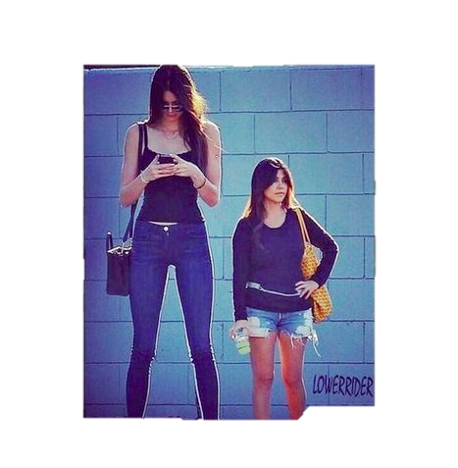Study the pictures and tell me what you see. (Teachers may use other images) Learners will give their evaluation and judgement on the pictures.

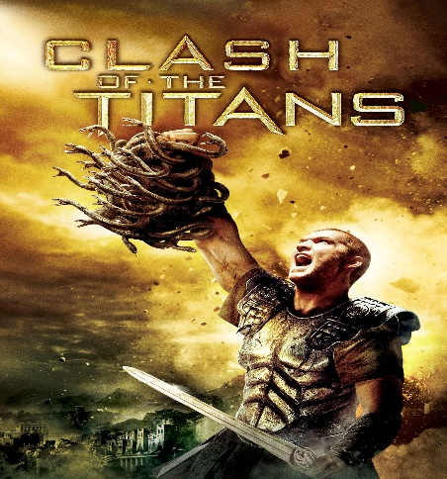

Picture B

Picture C

Picture A AA

1. Identify whether the sentence is subjective or objective in terms of evaluating and making judgements.
2. Lisa is taller than Maya.
3. The students wear their uniforms at school.
4. My friends told me that this movie is interesting.

Prepared by:

**GIGI LYN V. ATICALDO**- LYFJNNHS

**LYNN T. DIMACALI-** TVNHS

Submitted to:

**MA. GLECITA C. COLUMNA**

EPS- English and Journalism