**INFO SHEET #1: CRITIQUING A TEXT/LITERARY SELECTION**

**Competency**

**MELC: Compose an independent critique of a chosen selection.**

**Objectives**

After the end of the lessons, the learners are expected to be able to:

* identify the criteria in critiquing a text or literary selection.
* determine the parts of a critique; and
* write an independent critique of a chosen selection.

**Key Information**

**CRITIQUING A TEXT**

A critique is a genre of academic writing that briefly summarizes and critically evaluates a work or concept.

When we summarize a text, we capture its main points. When we evaluate a text, we consider how it has been put together—we dissect it to see how it works by asking questions.

**To critique a piece of writing is to do the following:**

• describe: give the reader a sense of the writer’s overall purpose and intent

• analyze: examine how the structure and language of the text convey its meaning

• interpret: state the significance or importance of each part of the text

• assess: make a judgment of the work’s worth or value

Writing a critique on a work helps us to develop a knowledge of the work’s subject area or related works, an understanding of the work’s purpose, intended audience, development of argument, structure of evidence or creative style, and recognition of the strengths and weaknesses of the work.

**FORMATTING A CRITIQUE**

Here are two structures for critiques, one for nonfiction and one for fiction/literature.

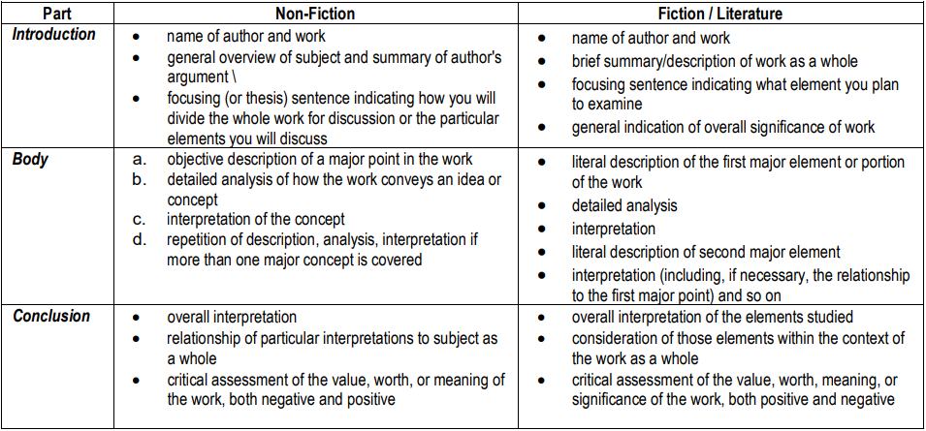

Here are some ideas to consider when critiquing a text:

• How did you respond to the piece? Did you like it? Did it appeal to you? Could you identify with it?

• Do you agree with the main ideas in the text?

• Did you find any errors in reasoning? Any gaps in the discussion?

• Did the organization make sense?

• Was evidence used correctly, without manipulation? Has the writer used appropriate sources for support?

• Is the author objective? Biased? Reasonable?

• Are the text’s tone and language text appropriate?