INFO SHEET #1: Visual- Verbal Relationship

Competency

MELC: EN8SS-IIe-1.2: Explain visual-verbal relationships illustrated in tables, graphs, and information maps found in expository texts.

Objectives

After the end of the lessons, the learners are expected to be able to:
1. Identify the different examples of non-linear texts.
2. Interpret the message/idea conveyed in non-linear texts.
3. Create a non-linear text that shows the data from the material gathered.

Key Information
VISUAL-VERBAL RELATIONSHIPS
Expository texts are designed to explain, inform, and present facts of specific topics. These texts can be accompanied by visual cues to provide or further highlight information.

Examples of these visual elements include graphs, tables, maps, illustrations, and the like. Their primary function is to improve comprehension of a reading material. However, understanding graphic elements like those cited above is an important aspect of comprehending texts that some tend to skip.

The concept of visual-verbal symbiosis is rooted in the idea that "visuals" support "verbals," and vice versa. Dwyer (1988) found a symbiotic relationship between verbal and visual literacies when the two are combined to facilitate student achievement.
I. Graphs
These are diagrams showing the relation between variable quantities, typically of two variables, each measured along a pair of axes at right angles.

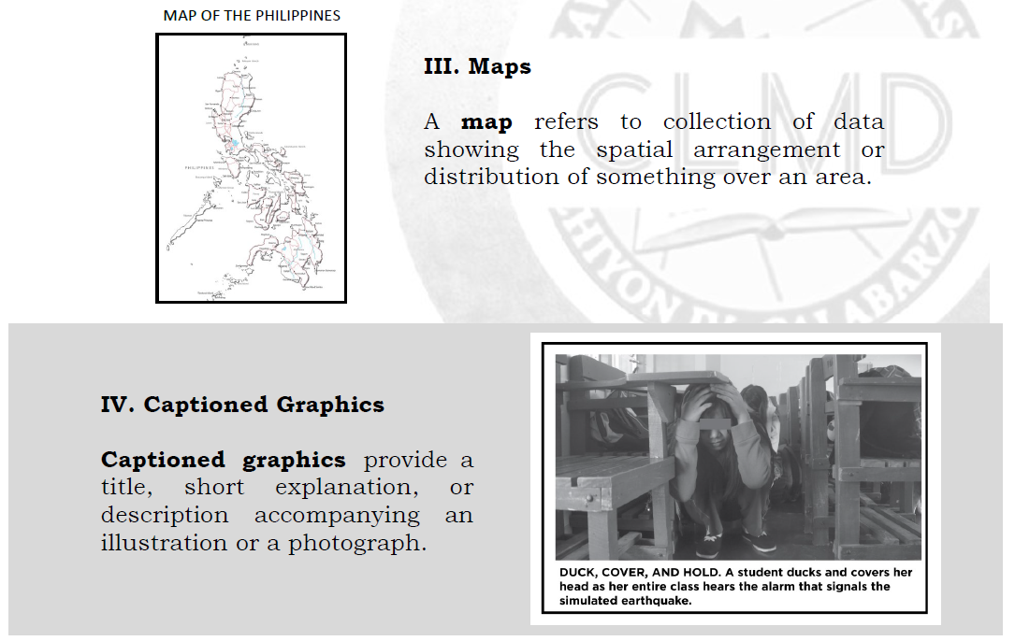

Reference:

Regional Office Management and Development Team & Schools Division Office Development Team. (2020). PIVOT IV-A Learner’s Material. English Grade 8 Quarter 1. (1st Edition). Department of Education Region IV-A CALABARZON.

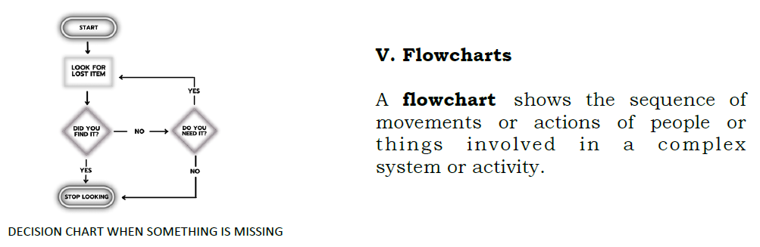

Reference:

Regional Office Management and Development Team & Schools Division Office Development Team. (2020). PIVOT IV-A Learner’s Material. English Grade 8 Quarter 2. (1st Edition). Department of Education Region IV-A CALABARZON.

Proposed Performance Tasks

Interpret Me:
Directions:
1. Divide the class into groups (depending on the class size).
2. Each group will conduct a survey. They will first choose a relevant topic, and then create a questionnaire regarding their chosen topic.
3. The students are expected to present the data they have gathered using the appropriate type of non-linear text assigned to

