**INFO SHEET #6: Compose a research report on a relevant social issue**

**Competency**

**MELC:** EN10SS- IVe-2- Compose a research report on a relevant social issue.

**Objectives**

After the end of the lessons, the learners are expected to be able to:

1. define questionnaire as part of the process of composing a research report;
2. identify different types of questions; and
3. develop a research questionnaire to help gather data for the research report.

**Key Information**

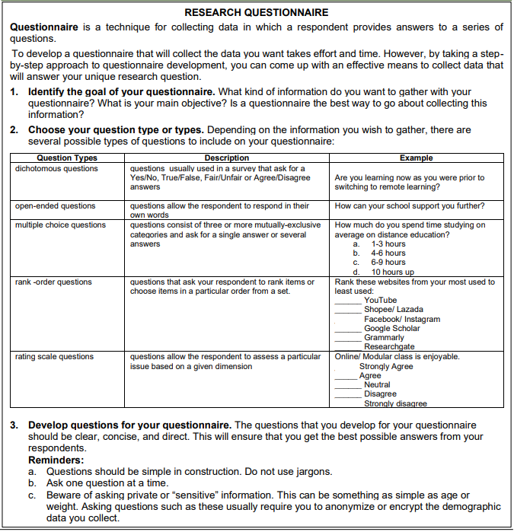

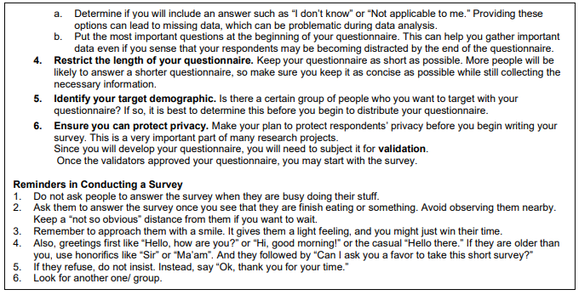

**Proposed Performance Tasks**

**On My Own!**

**Direction:** Using your chosen topic from the previous lesson, formulate at least two (2) questions for each type. Use the table given below for your answer.

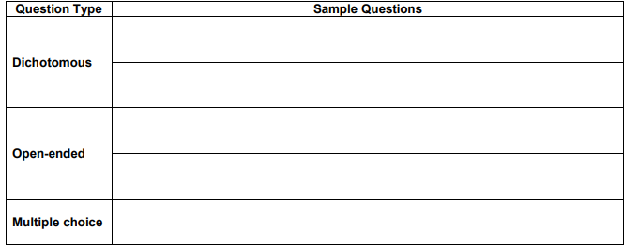

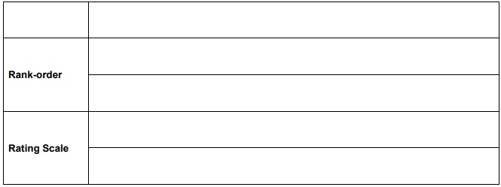

The questions you wrote will be graded using the rubric given below.

