**INFO SHEET #6.1: Compose a research report on a relevant social issue**

**Competency**

**MELC:** EN10SS- IVe-2- Compose a research report on a relevant social issue.

**Objectives**

After the end of the lessons, the learners are expected to be able to:

1. define methodology and identify its subheadings (parts);
2. determine the content of each subheading: and
3. write a research methodology as part of a research report.

**Key Information**

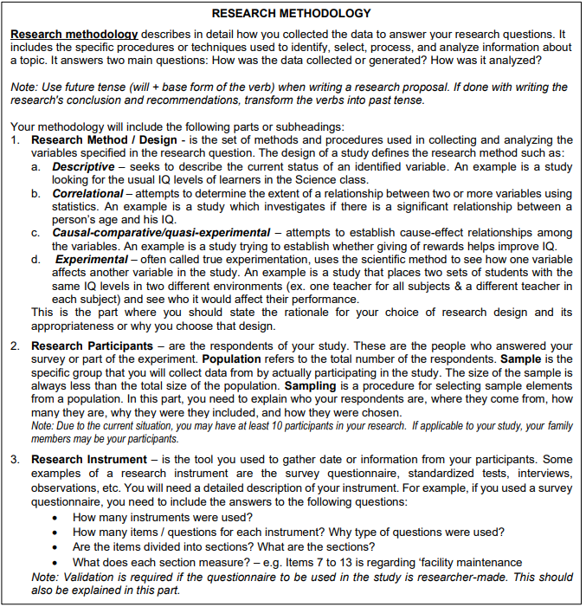

**Proposed Performance Tasks**

**On My Own!**

**Direction:** Using your chosen topic from the previous lesson, formulate at least two (2) questions for each type. Use the table given below for your answer.

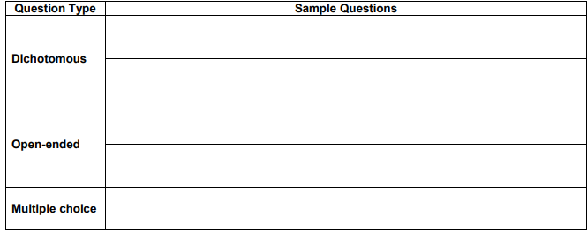

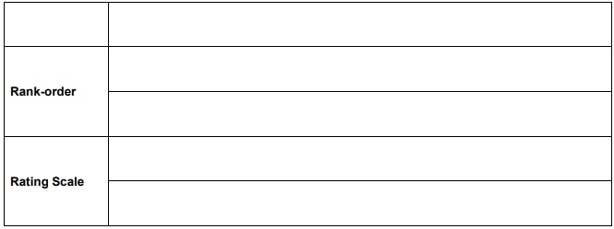

.

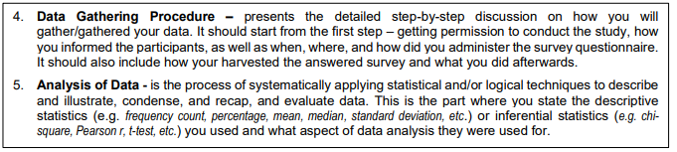

**Proposed Performance Tasks**

**Team Work Makes the Dream Work!**

Directions: You must work coherently as a team to plan, write, and organize your research methodology. Combine your answers and write your Research Methodology. You may write your completed Research Methodology on the space below or used another sheet of paper. Please be mindful of the indicators in the rubric before starting.

