INFO SHEET #5: Analytical Listening

Competency

MELC: EN10LC-lle-13.2. Employ analytical listening in problem solving.

Objectives

After the end of the lessons, the learners are expected to be able to:
- Identify the sequential process in analytical listening.
- Enhance learner’s auditory skills in listening thru note taking important details necessary in solving problems.
- Value the importance of analytical listening in gathering details and collecting information that will help them in giving solutions to problems listened to.

Key Information
Analytical Listening

Analytical listening, sometimes called critical or active listening, deals with one’s ability and capacity to carefully and properly analyze the sound/s listened to. This does not only involve comprehension on what has been heard, but more importantly, the ability to distinguish and categorize the information listened to.

This is also called active listening as it requires the listener to provide significant and evaluative feedback or response on what he/she has heard from the speaker or the sound platforms. In here, the listener can rephrase or restate the information heard to check one’s listening understanding. The features of analytical listening allow listeners and speakers to avoid miscommunication, misinterpretation, and misinformation. As such, comprehension and understanding are both ensured.

Analytical listening requires sequential process. These stages include the following:

Receiving Stage – refers to actual hearing process. In here, the listener has to check him/herself if he/she is able to hear clearly the sounds and other sound points.
Understanding Stage – focuses on generating meaning on what has been heard. In here, the connection on communication between the listener and the speaker must be clearly established. This constitutes the idea that the understanding of the speaker must be the same with the listener.

References:
Villalobos, John Lerry F. (2020). PIVOT 4A Learner’s Module Quarter 2 p. 7
Mensalvas, Athan (2014, August 15). Strategies for developing listening skills. Retrieved December 2, 2020, from https://www.slideshare.net/athanmensalvas/strategies-for-developing-listening-skills-38040043
Morley, Catherine (n.d.). Listening: Top down and bottom up. Retrieved December 2, 2020, from https://www.teachingenglish.org.uk/article/listening-top-down-bottom
Tennant, Adrian. (2020). Listening matters: Top-down and bottom-up listening. One-stop English. Macmillan Education Limited. Retrieved from https://www.onestopenglish.com/listening/listening-matters-top-down-and-bottom-up-listening/154567.article

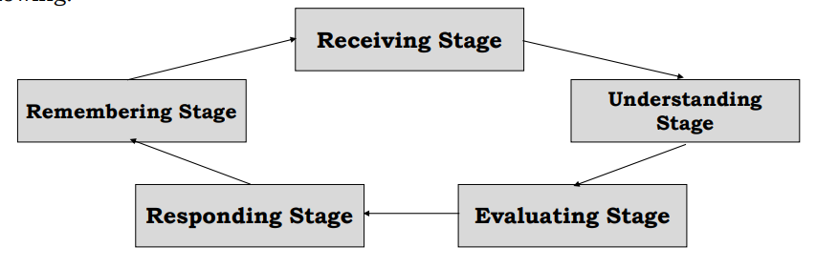

Evaluating Stage – requires both the listener and the speaker to meet in between regarding the points portrayed in the listening process. This allows the listener to critically examine the details of the information heard. This provides the time for information segregation.
Responding Stage – allows the listeners to provide verbal and/or non-verbal feedback and responses based on the listening contexts.
Remembering Stage – is a personal stage for the listener allowing his/her to integrate in him/herself the information heard. This also allows him/ her to record in his/her system the information listened to for future access and use.

Analytical listening is a very helpful strategy in problem-solving activities. In solving a particular issue or concern, it is important to identify first the significant information required.

In solving a problem in a listening text, the first task is to identify the problem. From the listening texts, find the answers for the following questions: who, what, how, when, where and why.

According to American Society for Quality (2020), there are four (4) steps in solving a problem which include the following:

1. Define the problem;
2. Generate alternative solutions;
3. Evaluate and select an alternative; and
4. Implement and follow up on the solution.

References:
Active Listening”. Retrieved from https://courses.lumenlearning.com/austincclearningframeworks/chapter/chapter-10-active-listening-in-the-classroom/
Problem-Solving”. Retrieved from https://asq.org/quality-resources/problem-solving

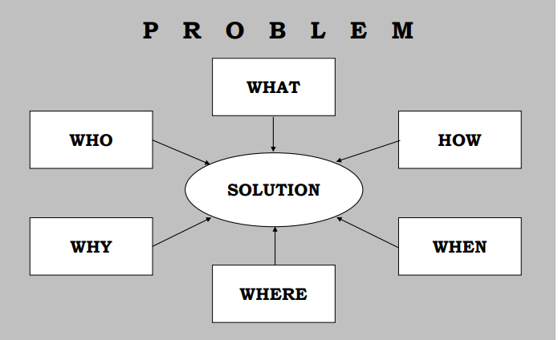

Proposed

Proposed Performance Tasks

I Hear Your Voice

In this task, the student will listen to a material and give/propose solution to problems tackled in it. (e.g. social issues, values integration, mathematical problems, scientific problems (teacher’s discretion))

Problems Identified | Proposed Solutions

