**INFO SHEET #2: ARGUMENTATIVE ESSAY**

**Competency**

**MELC:**

Identify Key Structural Elements: Exposition Statement of Position, Arguments, Restatement of Positions, and Language Features of an Argumentative text.

After the end of the lessons, the learners are expected to be able to:

1. Identify the modals used in writing argumentative texts.
2. Recognize the use of each modal as language in argumentation.
3. Express argument and position using modals.

**Key Information**

**Argumentative Essay** - conveys opinions that are proposed as true and justifiable. It presents arguments about both sides of an issue. A controversial issue always lies at the heart of an argumentative essay. The argument maybe in favor of (pro) or against (con) the said issue.

Argumentative Essay using Modals

|  |  |  |
| --- | --- | --- |
| **Certainty of Conclusion** | **Modal Verbs/Adverbs** | **Statement of Claim/Prompts** |
| Strong | is, will, can not, must, undoubtedly, always, never, definitely, clearly | It is certain that... It seems clear that... X is definitely... |
| Moderate | should, would, can, ought to, tends to, usually, likely, probably, regularly, majority, generally, often, frequently, rarely | It appears probable... It is usually the case that... In the majority of cases... The results suggest it is likely that... |
| Tentative | May, might, could, possible, conceivable, sometimes, occasionally, seldomly, perhaps, maybe, uncertainly, minority | Conceivably,... It is possible that... Occasionally,... It may be the case that... |

**Commonly Used Modal Verbs and Evaluative Language for argumentative essay**

**Transitional Devices**

-are words or phrases that help carry a thought from one sentence to another, from one idea to another, or from one paragraph to another. And finally, transitional devices link sentences and paragraphs together smoothly so that there are no abrupt jumps or breaks between ideas.

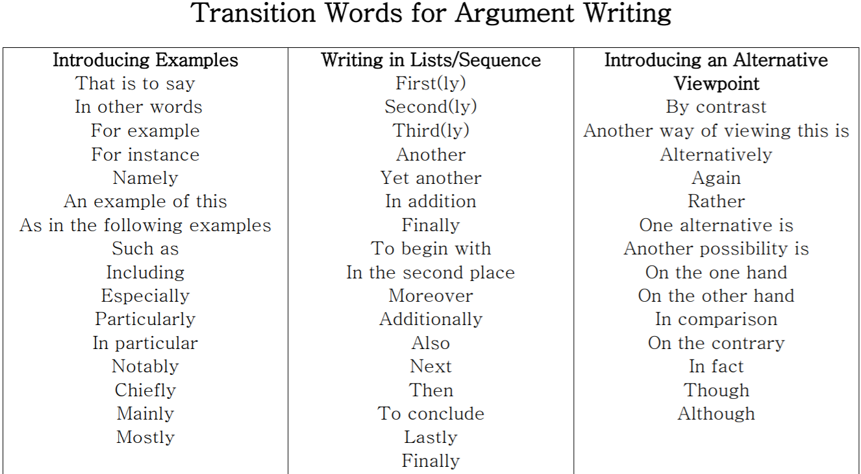

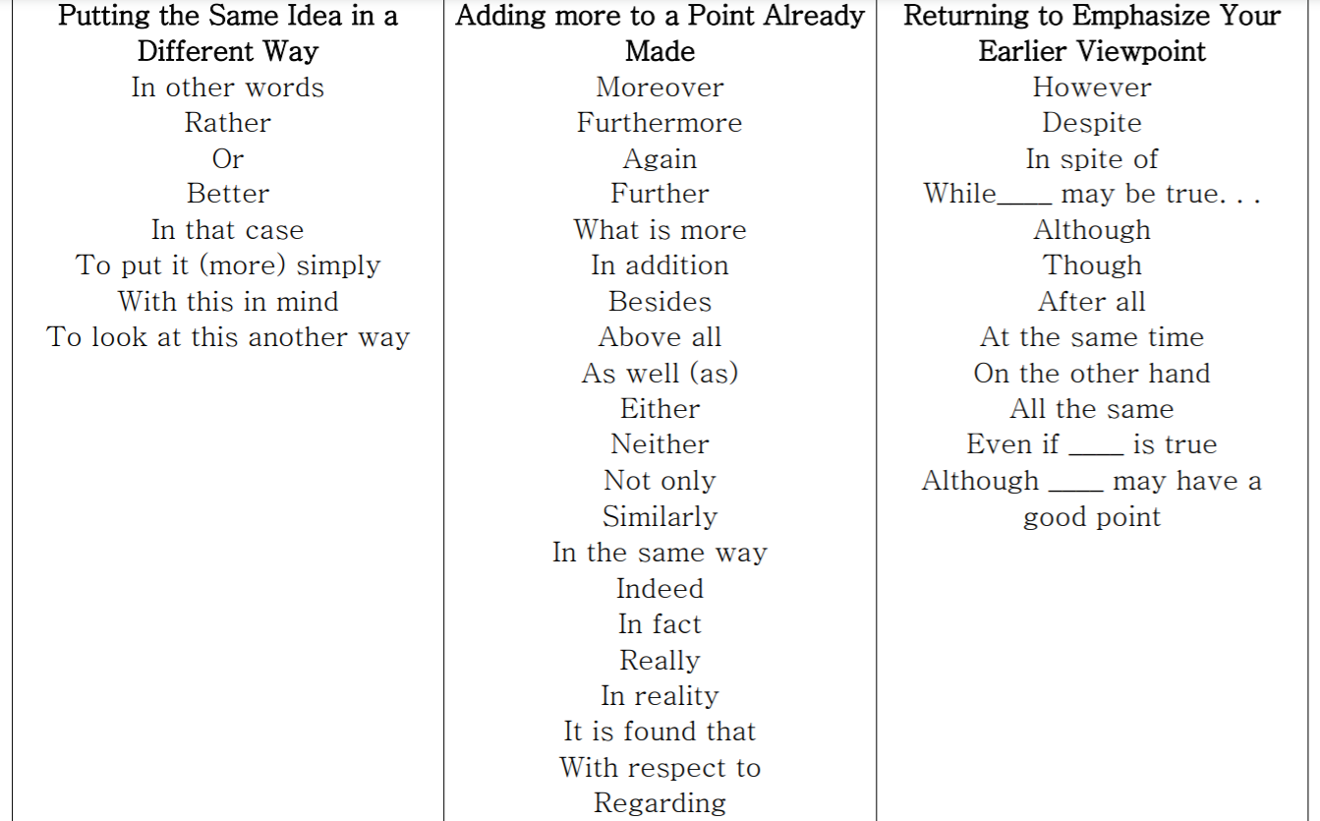

The general structure of an argumentative essay follows this format:

1. **Introduction -** Attention Grabber / [hook](https://literarydevices.net/hook/), [Background Information](https://literarydevices.net/background-information/), [Thesis](https://literarydevices.net/thesis/) Statement
2. **Body/discussion of content -** Three body paragraphs (three major arguments)
3. **Counterargument** - An [argument](https://literarydevices.net/argument/) to refute earlier arguments and give weight to the actual position
4. **Conclusion -** Rephrasing the [thesis statement](https://literarydevices.net/thesis-statement/), major points, call to attention, or [concluding remarks](https://literarydevices.net/concluding-remarks/).
5. **Credits -** is essential because giving credit to the creator of the source material helps you avoid plagiarism. Identifying your sources also helps your reader understand which written content is from a source and which represents your ideas.

**Use of rhetorical questions and passive voice in argumentative essay**

Rhetorical questions are used in various forms of writing and rhetoric. They can be found in literature and are often used in persuasive writing, like essays, debates, and speeches of all kinds, whether political or a commencement speech.

<https://www.lucidchart.com/blog/types-of-graphic-organizers-in-education>

References:

Villalobos, John Lerry F. (2020). PIVOT 4A Learner’s Module Quarter 2 p. 7

Mensalvas, Athan (2014, August 15). Strategies for developing listening skills. Retrieved December 2, 2020, from <https://www.slideshare.net/athanmensalvas/strategies-for-developing-listening-skills-38040043>

Morley, Catherine (n.d.). Listening: Top down and bottom up. Retrieved December 2, 2020, from https://www.teachingenglish.org.uk/article/listening-top-down-bottom

Tennant, Adrian. (2020). Listening matters: Top-down and bottom-up listening. One-stop English. Macmillan Education Limited. Retrieved from https://www.onestopenglish.com/listening/listening-matters-top-down-and-bottom-uplistening/154567.article

**Proposed Performance Tasks**

Write a sample argumentative text using correct structural elements and language features.

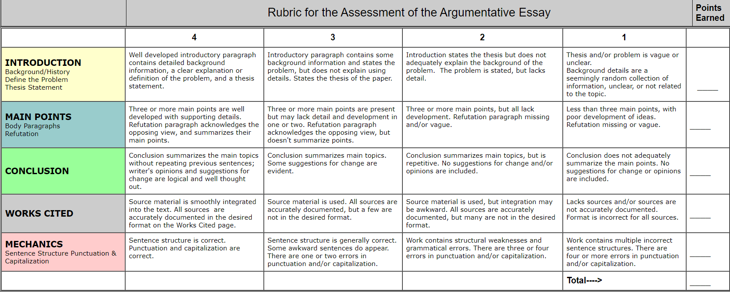

Rubrics for Assessment of Argumentative Essay. Retrieved from: [*http://sites.fas.harvard.edu/~ede104d1/rubrics/Rubric%20for%20the%20Assessment%20of%20the%20Argumentative%20Essay.htm*](http://sites.fas.harvard.edu/~ede104d1/rubrics/Rubric%20for%20the%20Assessment%20of%20the%20Argumentative%20Essay.htm)

*References:*

*Activities for argumentation. Retrieved from:* [*https://www.englishworksheetsland.com/grade7/writing/3/1argumentat.pdf*](https://www.englishworksheetsland.com/grade7/writing/3/1argumentat.pdf)

*Transitional Devices activity. Retrieved from:* [*https://quizizz.com/admin/quiz/5d49b5bf51f8ac001a47b23a/argumentative-essay-transitions*](https://quizizz.com/admin/quiz/5d49b5bf51f8ac001a47b23a/argumentative-essay-transitions)

*Transitional Devices activity. Retrieved from:* [*https://quizizz.com/admin/quiz/5d49b5bf51f8ac001a47b23a/argumentative-essay-transitions*](https://quizizz.com/admin/quiz/5d49b5bf51f8ac001a47b23a/argumentative-essay-transitions)

Words for Argument. Retrieved from: [*https://owl.purdue.edu/owl/general_writing/mechanics/transitions_and_transitional_devices/transitional_devices.html*](https://owl.purdue.edu/owl/general_writing/mechanics/transitions_and_transitional_devices/transitional_devices.html)

*Transitional Devices. Retrieved from:* [*https://www.qacps.org/cms/lib/MD01001006/Centricity/Domain/1442/transitionwordsargue.pdf*](https://www.qacps.org/cms/lib/MD01001006/Centricity/Domain/1442/transitionwordsargue.pdf) *Rhetorical Questions. Retrieved from:* [*https://www.grammarly.com/blog/rhetorical-question/#:~:text=Rhetorical%20questions%20are%20used%20in,political%20or%20a%20commencement%20speech*](https://www.grammarly.com/blog/rhetorical-question/#:~:text=Rhetorical%20questions%20are%20used%20in,political%20or%20a%20commencement%20speech)*.*

*Retrieved from: https://openoregon.pressbooks.pub/wrd/chapter/crediting-your-sources/*

Rubrics for Assessment of Argumentative Essay. Retrieved from: [*http://sites.fas.harvard.edu/~ede104d1/rubrics/Rubric%20for%20the%20Assessment%20of%20the%20Argumentative%20Essay.htm*](http://sites.fas.harvard.edu/~ede104d1/rubrics/Rubric%20for%20the%20Assessment%20of%20the%20Argumentative%20Essay.htm)