**INFO SHEET #3: Relevance and Truthfulness of Ideas**

**MELC:** Determine relevance and truthfulness of ideas presented in the material viewed.

**Objectives**

After the end of the lessons, the learners are expected to be able to:

1. analyze the information contained in the material viewed; and

2. recognize faulty logic, unsupported facts, and emotional appeal; and

3. evaluate the relevance and truthfulness of materials.

**Key Information**

**RELEVANCE & TRUTHFULNESS OF IDEAS**

Establishing the relevance and truthfulness of any material is an important part of evaluating any information presented in any form of media. It helps determine whether the material presents accurate and reliable data.

**RELEVANCE** refers to the degree to which something is related or useful to what is happening or being talked about. It considers the importance of the information and whether it answers the questions you have in mind. To determine relevance, the purpose and bias must be understood. The following questions may also be asked:

• How is the information useful to you? How well does it relate to the information you need?

• What details are provided that specifically address what you need?

• Is the work scholarly or popular?

• What is the purpose of this source? Is it to sell a product, educate, advocate, or persuade, or to entertain?

**TRUTHFULNESS**, on the other hand, implies honesty, trustworthiness, and integrity. It denotes complete

sincerity and accuracy in all details. The following questions may be asked to establish truthfulness:

• Is the source credible or verifiable? Do other sources have the same information?

• Is it accurate and completely true? Is it NOT misleading? Was any information omitted?

• Is it timely and not outdated?

**FALLACY** is an illogical step in the formulation of an argument. An argument in academic writing is essentially a conclusion or claim, with assumptions or reasons to support that claim.

Moreover, to determine the relevance and truthfulness of materials, the following may be considered:

**1. Faulty Logic**

Logic is the use and the study of valid reasoning, while faulty means mistaken or misleading because of

flaws. Therefore, faulty logic is an imperfect reason. Faulty logic is seen in newspaper editorials,

commercials, print ads, books, magazines, and TV shows.

Example: Nicholas Sparks is a wonderful writer because he writes so well.

*(The claim “wonderful writer” is supported by a restatement of the same claim, “writes so well.”)*

**2. Unsupported Facts**

Fact is something that has really occurred or is the case. Unsupported facts are those facts claimed by an individual or a group of individuals that have occurred but were unable to provide sufficient evidence to support their claim.

Example: People who live in Cavite are friendlier than those who live in Manila.

*(No evidence to back up statement.)*

**3. Emotional Appeal**

Appeal is the power of arousing a sympathetic response. An emotional appeal is a method of persuasion

that is designed to create an emotional response, which persuade audiences by arousing the emotions to move them to act.

Example: A telephone company advertisement shows a sweet grandmother sitting patiently by the phone, waiting for her loved ones to call.

(the image of a grandmother appeals to our emotions and may lead us to buy the product they are advertising)

**Suggested Performance Tasks:**

Viewing: Watch a music video from a popular romantic tragic play, “Romeo & Juliet”. (<https://www.youtube.com/watch?v=4FHpmn-KYec>)

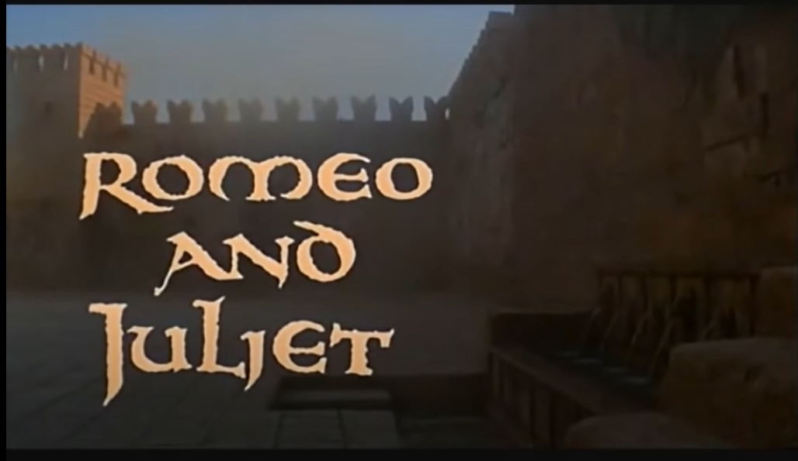

Describe one scene from the video that presents each of the following:

1. Faulty logic

2. Unsupported facts

3. Emotional appeal