**INFO SHEET #3: Recognizing Positive and Negative Messages**

**Competency**

**MELC:** Recognize positive and negative messages conveyed in a text.

**Objectives**

After the end of the lessons, the learners are expected to be able to:

1. Discern the positive and negative message conveyed in the text,
2. Construct sentences applying tone words indicating positive and negative messages, and;
3. Create a poster slogan about certain topic using tone words

**Key Information**

**POSITIVE AND NEGATIVE MESSAGES**

**Positive messages** include messages where the audience is expected to react in a neutral to positive manner. Positive messages tend to consist of routine or good news. These messages might be items such as congratulations, confirmations, directions, simple credit requests, or credit approvals.

**Negative messages** include things such as: refusals, rejects, recalls, announcements of policies that will not benefit the audience, requests the audience will see as insulting or intrusive, negative performance appraisals, disciplinary notices, and apologies.

Writers use tone words to establish a message. These are words that make the author’s opinion on the subject matter known. They make the tone either positive or negative.

**Gender-Neutral language** – words that are not gender specific and refer to people in general with no reference to men and women.

Example: policeman/policewoman – police officer

chairman – chairperson

spokesman – spokesperson

landlord – land owner

mankind – humankind

**Euphemism** – replacing a word or phrase with another in order to make sentences sound less offensive.

Example: died – pass away cemetery - boneyard

garbage man – sanitation engineer prison – correctional facility

old people – senior citizen bossy - outspoken

Source: Lumen Learning Business Communication Skills for Managers. The Right Message. Retrieved Dec. 14, 2020 from https://courses.lumenlearning.com/wm-businesscommunicationmgrs/chapter/the-right-message/ Moreno, Melanie Mae N. (2020). PIVOT 4A Learner’s Module Quarter 2. p. 33-34

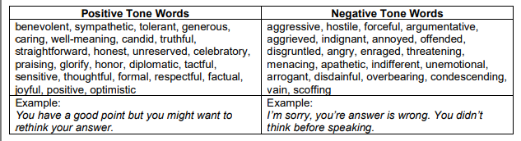

**Colloquial** – familiar expression used in ordinary conversation , not formal or literary.

Example: You’re nuts! Go bananas!

Don’t chicken out! I wasn’t born yesterday!

**Slang** – Informal use of language by certain groups of people specifically teenagers.

Example: **Glow-up** – means makeover or transformation from bad to good.

**Ghosting** – this term is common in the earlier talking stages of a relationship It means you start ignoring them or stop texting them back.

**Yikes** – when you’re so embarrassed

**Sheesh** – to hype someone up if they’re looking good or doing something good.

**Iykyk** - This acronym is short for "if you know, you know." It's commonly used in reference to an inside [joke](https://parade.com/940979/kelseypelzer/best-dad-jokes/) or something only a specific community might understand.

**Bet** - Simply put, this slang term means "yes." It can be used to confirm something and could be compared to the Millennial term "word.

**Sis** - A shortened version of "[sister](https://parade.com/938637/parade/sister-quotes/)," this term is typically used to greet a friend, no matter their gender.

**G.O.A.T**. - Short for "The Greatest of All Time." An acronym used to describe someone incredible.

**Proposed Performance Tasks**

***LET’S MAKE PAN*** *(positive-and-negative) MESSAGES*

Group activity:  Each group will make messages and statements with positive and negative effects of social media on the lives of young students.

Present the output through the following topics:

* Song
* Quotations
* Short story
* Dialogue
* Poster/ Slogan