**INFO SHEET #7: SPOKEN TEXT**

**MELC:**

Deliver a prepared speech or impromptu talk on issue employing the techniques in public speaking

**Objectives**

At the end of the lesson, the learners are expected to:

1. enumerate techniques which may be employed in various forms of public speaking;

2. critique a speech using a given set of criteria; and,

3. make a slogan about techniques in public speaking

**Key Information**

**Prepared Speech** – the speaker is given the topic beforehand, has time to research about the topic, and

can rehearse or practice prior to delivering the speech.

**Impromptu Speech** – the speaker is given with little or no time to prepare. This type of speaking occurs

during ambush interview and other gatherings where people are asked to deliver a speech on the spur of

the moment.

**Spoken text** is different from written text for many reasons. One important reason is that it usually has to be understood immediately whereas written language can be read many times. For that reason, spoken language has many different features.

* Variation in speed - but it is generally faster than writing
* Loudness or quietness
* Gestures - body language
* Intonation
* Stress
* Rhythm
* Pitch range
* Pausing and phrasing

**Spoken text Composition**

* Spoken language is grammatically less complex than written language. It has fewer subordinate clauses, fewer "that/to" complement clauses, fewer sequences of prepositional phrases, fewer attributive adjectives and more active verbs.
* Spoken texts are longer. This means that there is more repetition.
* Spoken texts also have shorter, less complex words and phrases.
* Have fewer nominalizations, more verb-based phrases, and a more limited vocabulary.

**Receiving Stage –** refers to actual hearing process. In here, the listener has to check him/herself if he/she is able to hear clearly the sounds and other sound points.

**Understanding Stage** – focuses on generating meaning on what has been heard. In here, the connection on communication between the listener and the speaker must be clearly established. This constitutes the idea that the understanding of the speaker must be the same with the listener.

References:

Villalobos, John Lerry F. (2020). PIVOT 4A Learner’s Module Quarter 2 p. 7

Mensalvas, Athan (2014, August 15). Strategies for developing listening skills. Retrieved December 2, 2020, from https://www.slideshare.net/athanmensalvas/strategies-for-developing-listening-skills-38040043

Morley, Catherine (n.d.). Listening: Top down and bottom up. Retrieved December 2, 2020, from https://www.teachingenglish.org.uk/article/listening-top-down-bottom

Tennant, Adrian. (2020). Listening matters: Top-down and bottom-up listening. One-stop English. Macmillan Education Limited. Retrieved from https://www.onestopenglish.com/listening/listening-matters-top-down-and-bottom-up-listening/154567.article

* have proportionately more grammatical words than lexical words.
* Spoken text has more words that refer to the speaker, more quantifiers and hedges, and less abstractness.

**Traditional delivery**

There are four basic methods of speech delivery: manuscript, memorized, impromptu, and extemporaneous.

**1. Manuscript**

A manuscript speech is when the speaker writes down every word he/she will speak during the speech. When they deliver the speech, they have each word planned and in front of them on the page, much like a newscaster who reads from a teleprompter**.**

**2.** **Memorized**

A memorized speech is also fully prepared in advance and one in which the speaker does not use any notes. Memorizing a speech isn’t like memorizing a poem, Work with an outline. Practice with the outline until you can recall the content and order of your main points without effort. Then it’s just a matter of practicing until you’re able to elaborate on your key points in a natural and seamless manner.

### 3. Impromptu

An impromptu speech is one for which there is little to no preparation.  that there is no time for preparation, so finding research to support claims such as quotes or facts cannot be included. The lack of preparation makes some speakers more nervous and they may struggle to engage the audience

**4**. **Extemporaneous**

When speaking extemporaneously, speakers prepare some notes in advance. This is considered as the ideal speaking method because it allows speakers to be prepared, keeps the audience engaged, and makes the speakers more natural in their delivery.

***A multimedia presentation*** can be explained as a presentation including information and data that is presented by video, images, and animation, or a digital presentation that includes audio, narration, music, and sound effects to deliver your messages to the audience.

* **Podcast** - a digital audio or video file or recording, usually part of a themed series, that can be downloaded from a website to a media player or computer.
* **TED talk (Technology, Entertainment and Design)** - A TED talk is a recorded public-speaking presentation that was originally given at the main TED (technology, entertainment and design) annual event or one of its many satellite events around the world. TED is a nonprofit devoted to spreading ideas, usually in the form of short, powerful talks, often called "TED talks."

**Techniques in Public Speaking**

1. Know your purpose. 8. Watch your words.

2. Be familiar with your topic. 9. Speak with clarity.

3. Consider your audience. 10. Know the essential etiquettes.

4. Plan ahead of time. 11. Use visuals when necessary.

5. Use non-verbal cues. 12. Dress comfortably, but appropriately.

6. Remain calm. 13. Be open to questions and comments.

7. Practice.

* **Vlogs** - A vlog is a shortened term for the phrase "video blog." A blog is a webpage where an author writes regular updates, usually about a particular topic. Most bloggers use a conversational tone when they write so they can connect better with their audiences.
* **Pecha Kucha - The word “PechaKucha” is Japanese for “chit chat.”**A Pecha Kucha presentation is a format that uses 20 slides or images that are displayed for 20 seconds each. The slides will move automatically as the presenter is speaking. This format ensures that the speaker is concise, keeps the presentation moving, and gets through all of their content. Although it is an uncommon format, it is most often used for creative disciplines to share their work or for professionals to share a journey or story.
* PechaKucha was created in Japan in 2003 by renowned architects, Astrid Klein and Mark Dytham. The word “PechaKucha” is Japanese for “chit chat.”
* **Pitch Presentation -** A pitch presentation is a short presentation in which you introduce your company, product or idea. You only have a few minutes to convince your audience and attract potential investors. So you need to plan what you want to say really carefully.

|  |  |
| --- | --- |
| Informative Speech vs. Argumentative Speech | |
| is intended to deliver information | Is intended to alter the readers viewpoint |
| Can be as entertaining and engaging as the speaker makes it | Features calmer tone |
| is used to educate and train the audience. | aims to prove the argument |
| need to understand the level of knowledge the audience need | Uses facts, reasons, and evidence |

**TECHNIQUES IN PUBLIC SPEAKING**

1. Know your purpose. 8. Watch your words.
2. Be familiar with your topic. 9. Speak with clarity.
3. Consider your audience 10. Know the essential etiquettes.
4. Plan ahead of time. 11. Use visuals when necessary.
5. Use non-verbal cues. 12. Dress comfortably, but appropriately.
6. Remain calm. 13. Be open to questions and comments
7. Practice

**Proposed Performance Tasks**

**Tech Talk :** Deliver a short prepared speech (e.g. political speech, advocacy, etc.) thru multimodal elements.

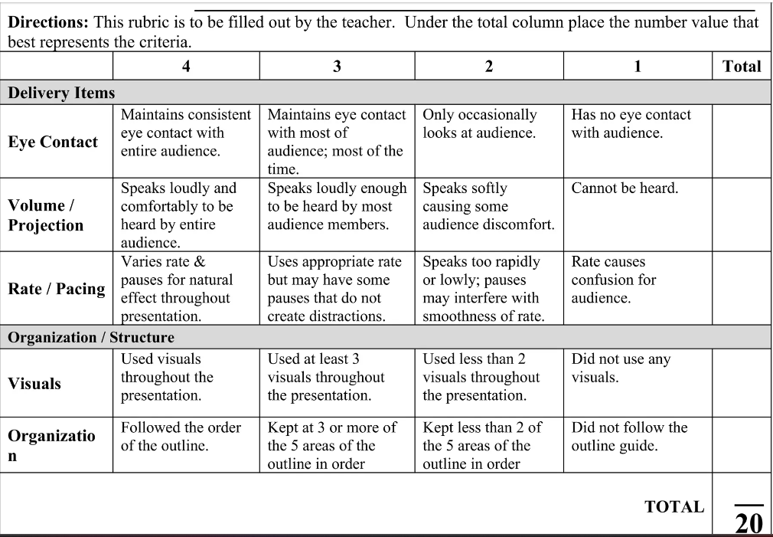

http://www.uefap.com/speaking/feature/complex.htm

https://courses.lumenlearning.com/wm-publicspeaking/chapter/methods-of-speech-delivery/

https://www.cedarville.edu/insights/computer-help/post/what-is-a-pecha-kucha-presentation

<https://difference.guru/difference-between-informative-and-persuasive-speeches/>