
DIVISION OF GEN. TRIAS CITY

Project ISuLAT Activity Sheets in Science 7

(Intensified Support to Learning Alternatives Through Modules and Worksheets)

Grade 7 - Quarter 3_Week 3

Name:_________________________________________________Grade & Section:______________

Teacher: ______________________________________________ Score:________________________

Activity Sheet No. 2: Visual Representation of the Motion of an Objects

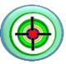 START UP

At the end of this worksheet, the learners will be able to:

- Describe the motion of an object.

- Analyze or represent motion of objects using charts, diagrams, and graphs.

- Appreciate the motion of an object through creative visuals.

Describing exact position entails two ideas:

- describing how far the object is from the point of reference; and

- describing its direction relative to that point of reference.

The position of an object can be described in different ways. You can use words, visuals, diagrams, and also graphs.

 CAPTURE

- Motion is an object's change in position relative to another object, or reference point.

- The object that appears to stay in place is called a reference point.

- The direction of an object's motion can be described with a reference direction, such as North, South, East, West, up or down.

- The positions of the objects can be described by diagram by their coordinates along the number line.

- Another way to describe the motion of an object is by the use of motion graphs.

INTEGRATE

Learning Task No.1. Using diagrams

Consider the diagram in Figure 1. The positions of the objects are described in the diagram by their coordinates along the number line.
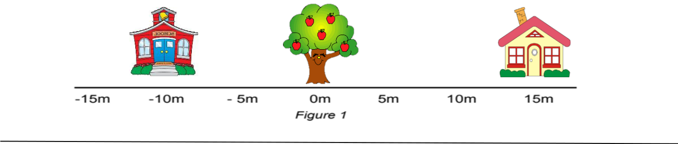

Page 1 of 4
DIVISION OF GEN. TRIAS CITY

Project ISuLAT Activity Sheets in Science 7

(Intensified Support to Learning Alternatives Through Modules and Worksheets)

Q1. What is the position of the school? __________

Q2. What is the position of the tree? __________

Q3. What is the position of the school with respect to the house? _________

Q4. What is the position of the tree with respect to the school? ___________

Here is another example. In this diagram, the positions of the ball rolling are shown at equal intervals of time. You can use the diagram to describe the position of the ball at any given time.
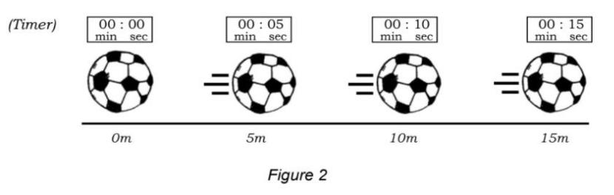

Q1. What is the initial position of the ball? What is its final position? _________

Q2. What is the position of the ball at 10 seconds? __________

Q3. At what time is the position of the ball equal to 5 meters? ____________

Learning Task No. 2. Using graphs

Another way to describe the motion of the ball is by the use of motion graphs.

Convert the diagram in Figure 2 to graph by following the guide below.

I. Fill up Table 1 using the data in Figure 2. Note that the positions of the ball are shown every 5 seconds.

Table 1: Position of the ball vs time

Time (s) | Distance (m)
0 | 0

- Plot the values in Table 1 as points on the graph in Figure 3. Note that time is plotted on the X-axis while position is plotted on the Y-axis. An example is given below.
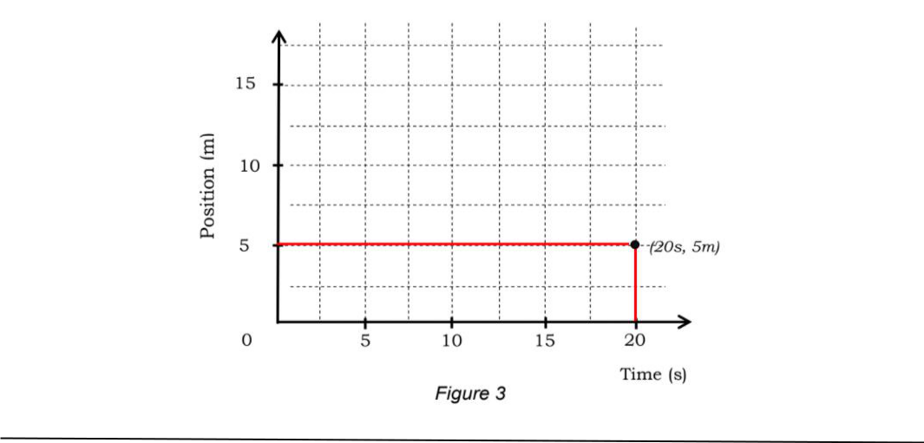

Page 2 of 4
DIVISION OF GEN. TRIAS CITY

Project ISuLAT Activity Sheets in Science 7

(Intensified Support to Learning Alternatives Through Modules and Worksheets)

The graph that you have just drawn in Figure 3 is called position-time graph.

You can also use this graph to describe the position of the ball at any given time.

 ENRICH

Performance Task No. 2:

Directions: Make your own COMMUNITY MAP. Put some reference point, labels, and estimated distance of one object to another. Use the sample below as your guide.
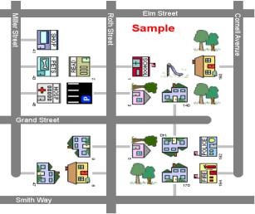

edHelper.com - Community Maps. https://www.edhelper.com/community2_1_0.htm

Rubrics for Drawing/ Illustration

 | Criteria |  | 4 | 3 | 2 | 1
 | 1. | Content | Shows better | Shows good | Shows fair | Shows poor
 |  |  | understanding | understanding | understanding | understanding
 |  |  | of the concept | of the concept | of the concept | of the concept
 | 2. | Creativity | Shows | Shows fair | Shows little | Shows poor
 |  |  | expressiveness | expressiveness | expressiveness | expressiveness
 |  |  | of imagination | of imagination | of imagination | of imagination
 | 3. | Labels | 90-100% of the | 89-80% of the | 79-70% of the | Less than 70%
 |  | and | labels/features | labels/features | labels/features | of the
 |  | Features- | can be read | can be read | can be read | labels/features
 |  | Neatness | easily. | easily. | easily. | can be read
 |  |  |  |  |  | easily.
 | Possible Highest |  | Score: 12
Possible Lowest Score: 3

Page 3 of 4
DIVISION OF GEN. TRIAS CITY

Project ISuLAT Activity Sheets in Science 7

(Intensified Support to Learning Alternatives Through Modules and Worksheets)

References:

Science 7. Learners’ Material pages 131-136

Internet Sources

Motion - Grade 7 Science. Google Sites.

https://sites.google.com/site/cmppjt/motion.

Chapter 2: Representing Motion. http://igcse-physics--41-p2yrh.brentsvillehs.schools.pwcs.edu/modules

https://clipartix.com/clip-art/

Page 4 of 4

